6.73: a) 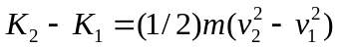
b) The work done by gravity is , so the work done by the rider is 

